



SRI VENKATESWARA COLLEGE OF ENGINEERING

# Project submitted by:-

TEAM LEADER: VADLA LAKSHMI SWETHA

TEAM MEMBER:

* Vadanapalli Kiranmai
* Vempalli Bharathkumarreddy
* Vemulapati Naveenreddy * Vardi Pavanvishnu

**Orange HRM Automation Testing Project**

**About Orange HRM :**

**OrangeHRM Inc.** is a HR software company based in [Secaucus, New Jersey](https://en.wikipedia.org/wiki/Secaucus,_New_Jersey), best known for its [Human resource management system](https://en.wikipedia.org/wiki/Human_resource_management_system). OrangeHRM was founded by Sujee Saparamadu in 2005. OrangeHRM offers starter and advanced version for its clients.

Founder and CEO of OrangeHRM Sujee Saparamadu, started OrangeHRM in 2005 with four employees. OrangeHRM 1.0 was a free and open source version released to Sourceforge in March 2006. 1.0 comprised features such as employee information management, employee self-service, and reporting.

In 2010 OrangeHRM received a Series A investment from principal investors Larry Stefonic and David Axmark. David Axmark. David Axmark is also a co-founder of [MySQL AB](https://en.wikipedia.org/wiki/MySQL_AB) and a developer of the free database server, [MySQL](https://en.wikipedia.org/wiki/MySQL), is on the board of directors.

**Table of Contents**

## • Introduction • Project Overview • Getting Started • Prerequisites • Installation • Project Setup • Project Structure • Writing Test Cases • Running Tests • Test Reporting • Troubleshooting

• Conclusion **Introduction**

The Orange HRM project is a Katalon automation project that utilizes the Selenium framework for automating web interactions. This configuration documentation provides an overview of the project, instructions for installation and, details about the project structure, and examples of test cases.

**Project Overview**

The Orange HRM project aims to automate various tasks on the Orange HRM website. It leverages Katalon studio, a powerful web automation tool, to interact with web elements and perform actions such as clicking buttons, filling forms, and extracting data.

## Milestone 1: Getting Started

Explain the prerequisites and setup required to run the project.

### Activity 1:-Prerequisites

Before getting started with the Orange HRM project, ensure you have the following prerequisites:

List the software and tools that need to be installed before running the project, such as:

* **Katalon Studio (Latest Version)**
* **Any other dependencies**

### Activity 2:-Installation

To install the necessary dependencies for the Orange HRM automation project, follow these steps:

**Activity 2.1:-** Install Katalon Studio: Visit the Katalon Studio website [(https://katalon.com/download )](https://katalon.com/download) and download the latest version of Katalon Studio.

Follow the installation instructions for your operating system.

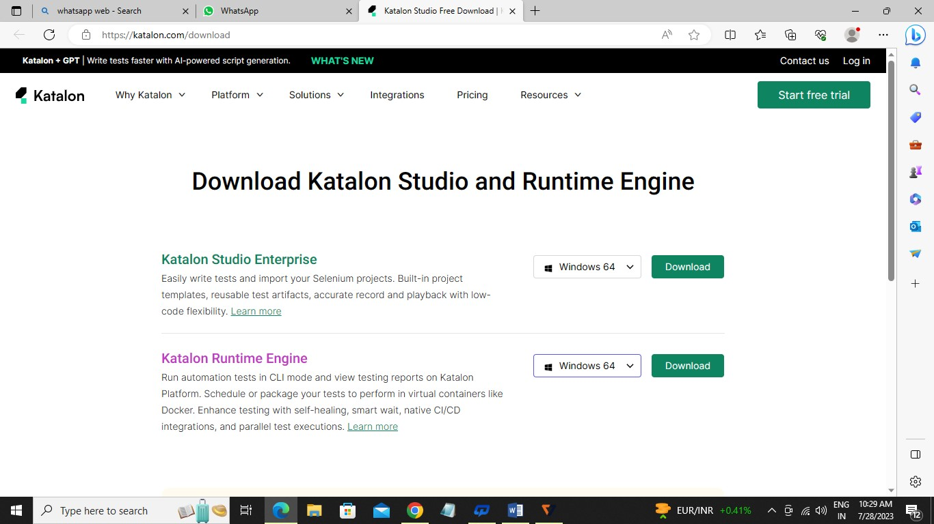

After downloading Katalon Studio and extracting the contents from the zip file, locate the folder where you extracted it.

In that folder, look for the "**katalon.exe**" file. This file is the executable for Katalon Studio.

Double-click on the "**katalon.exe**" file to launch Katalon Studio. It may take a few moments to start up.

Once **Katalon Studio** is launched, you can start creating or opening your project by selecting "File" from the menu bar and choosing either "**New Project**" or "Open Project" based on your requirements.

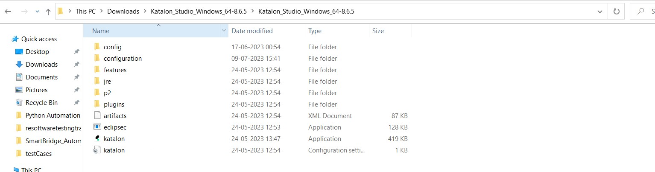

**Activity 2.2:-** Download and install **gitbash** from <https://git-scm.com/download/win>

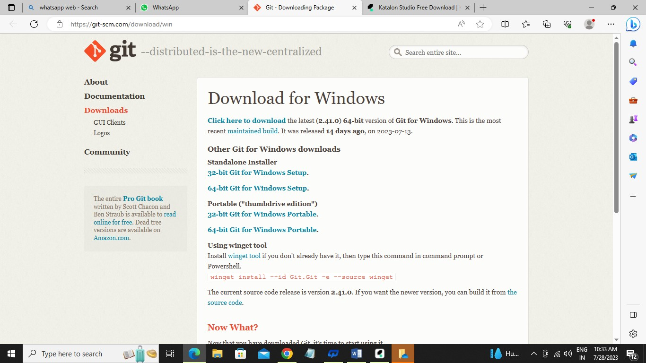

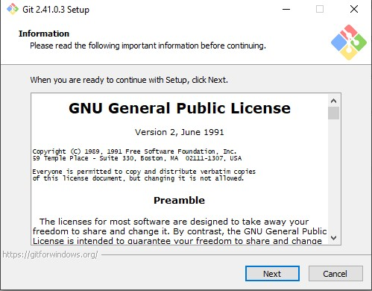

**Activity 2.3:-** Go to the desired location where you want to create the folder, such as Desktop. Folder name like eg…(Automation_Testing_Project)

Open the folder-→ Right click with in the folder and select open gitbash here, you will get pop up like below and clone the repository based on the next steps provided below.

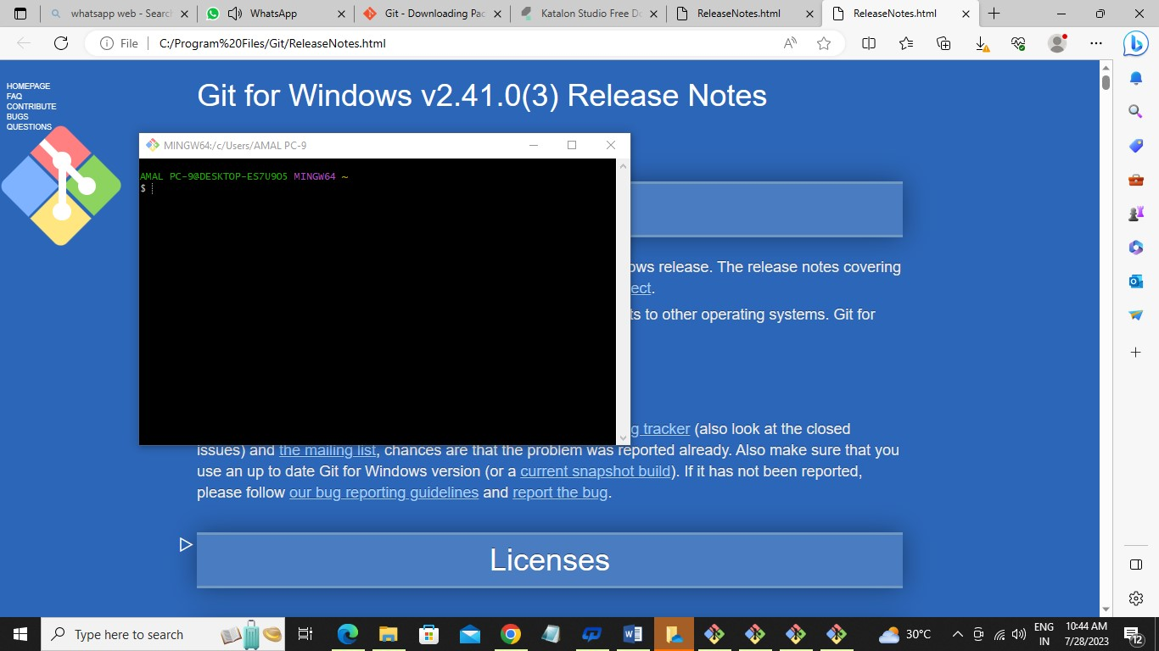

### Activity 3:- Project Setup

Explained how to set up the project locally, including steps like:

Before cloning the project create project like below in Katalon Studio.

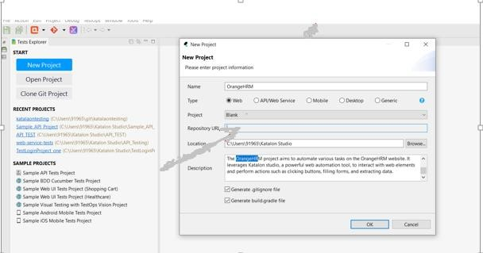

**Activity 3.1:-** Clone the repository from github.

**Activity 3.2:-** Enter the repository URL and click ok. Repo URL provided below.

**Activity 3.3:-** Clone the Orange HRM project repository from [repository URL].

<https://github.com/venkatsaitesting123/SmartBridge_Automation_Projects.git>

**Activity 3.4:-** Configuration settings (if any)

## Milestone 2: Project Structure

**Activity 1:-**Explained the structure of the project, including directories and files, and their purposes. For example:

* **testscases/**: Directory containing test scripts
* **ObjectRepository/**: Directory containing page object models
* **testSuites/**: Directory containing run multiple test cases
* **reports/**: Directory containing test reports
* **datafiles/**: Directory containing test data (**ex:excel,csv,text,json files**) related to project
* **Run :- Option to run all the testcases from the top quick access tool bar.**

**Activity 2:-Writing Test Cases**

Explained how to write test cases using Katalon Studio(it uses internally java,groovy script). Provide examples of different types of test cases, such as:

* Test case 1: Home Page functionality Screenshot of the code:

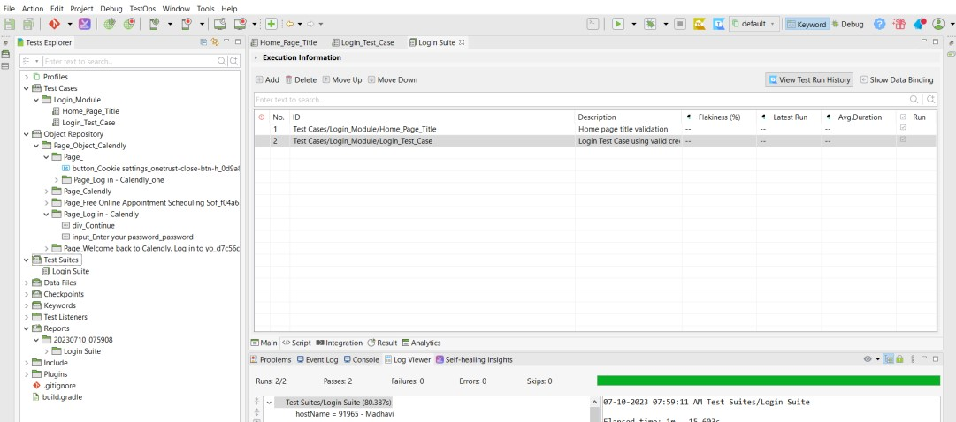

* Test case 2: Register new user functionality
* **Add new testcases as per Manual testcases prepared.**

Include best practices for writing maintainable and readable test cases.

## Milestone 3: Running Tests

Explained how to run the test cases using Katalon studio. Include information about command-line options and flags that can be used to customize test execution.

**Activity 1:- Option to run all the testcases from the top quick access tool bar.**

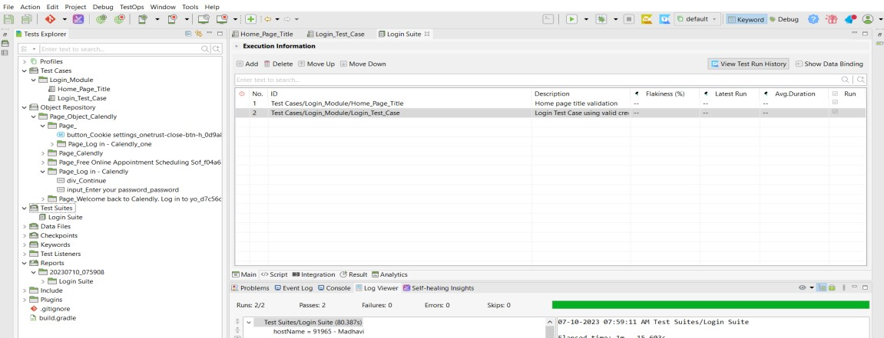

## Milestone 4: Test Reporting

Explained how test reports are generated and where they are stored. Include information about any tools or libraries used for reporting, such as katalon reporting.

**Activity 1:-reports/**: Directory containing test reports

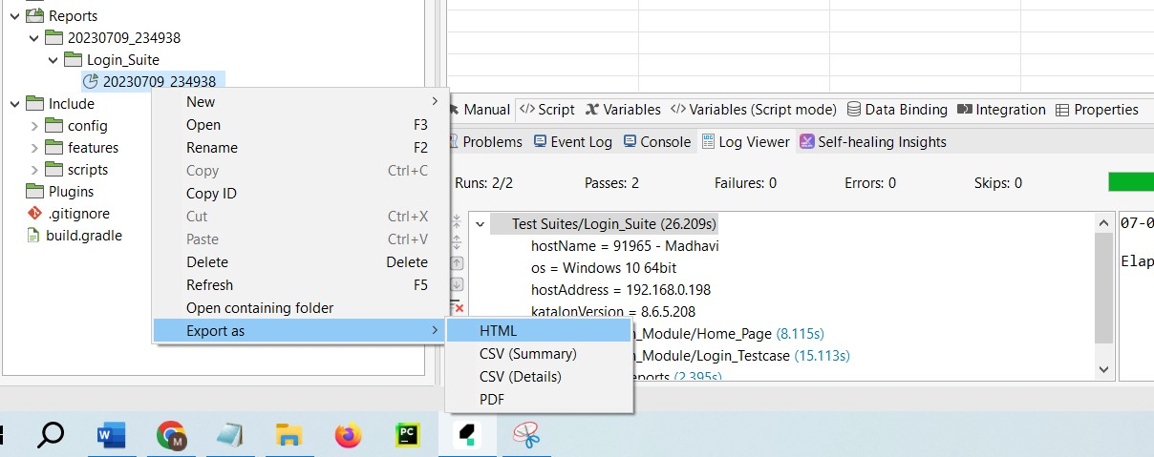

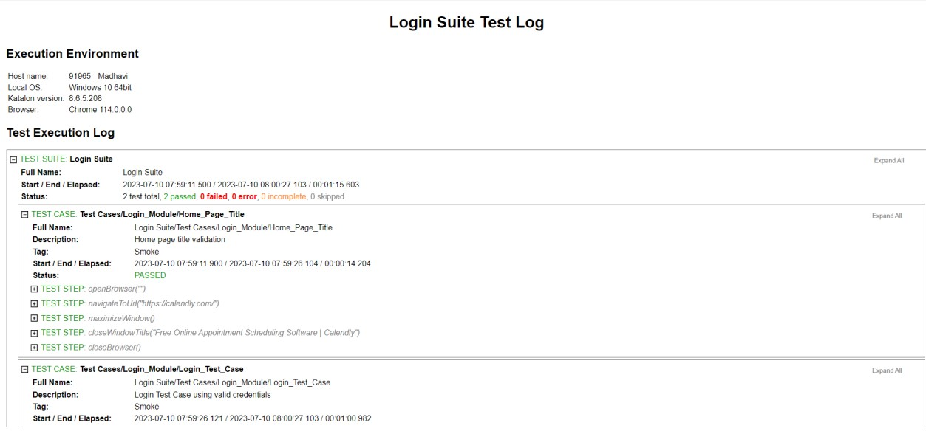

**Troubleshooting**

List common issues that may occur during project setup or test execution and provide possible solutions.

## Conclusion

The Orange HRM automation project provides a framework for automating various tasks within the Orange HRM web application using Katalon Studio. With this documentation, you should be able to set up the project, execute tests, and extend/customize it according to your needs.